Contents
1.0 Introduction 1
2.0 Scope 1
3.0 Responsibilities 1
4.0 Procedure 2
4.1 Eligibility 2
4.2 Identification of eligible patients and submission of tumour samples 2
4.3 Submission of germline DNA samples 4
4.4 Record of patient choice discussion 6
4.5 Sample tracking 7
4.6 Return of WGS reports and MDT discussion 7
5.0 References 8
6.0 Related Documents 8
7.0 Monitoring compliance with and the effectiveness of this document 8

1.0 Introduction

Whole genome sequencing (WGS) is commissioned for patients with acute leukaemia, childhood malignancies and sarcoma. Unlike current standard of care testing, which will initially be performed in parallel, WGS has the potential to detect all types of somatic and germline mutations (small, structural & copy number variants) in a single test without the need for multiple interrogations of the sample. To gain maximum information from WGS, tumour and germline DNA samples are sequenced simultaneously, allowing subtraction of germline variants from the somatic genome and meaning there is clear differentiation between germline and somatic variants. In the East Midlands and East of England (EMEE), WGS will require receipt of the following at the GLH DNA extraction laboratory in Cambridge:
- a Genomic Medicine Service WGS Test Request (Cancer)
- an appropriate tumour sample
- a germline (constitutional) sample
- a signed record of a patient choice (consent) discussion
Sample collection from most sites and integration of reports with other modalities of diagnostic testing will be coordinated through existing SIHMDS (Single Integrated Haematological Malignancy Diagnostic Service) networks in Cambridge, Leicester and Nottingham.

2.0 Scope

This document provides information for clinical teams regarding the eligibility criteria, requesting procedures, sample collection and transportation, discussion and recording of patient choice and receipt of reports for acute leukaemia WGS in the EMEE Genomic Laboratory Hub (GLH).

3.0 Responsibilities

SIHMDS haematopathologists (or clinical haematologists where an SIHMDS is not used) are responsible for requesting WGS for eligible patients and identifying appropriate tumour samples. Clinical haematologists are responsible for ensuring that patients who are eligible for WGS are invited to undergo collection of a germline sample and a documented discussion (consent) about genomic testing.

4.0 Procedure

The pathway is summarised in Figure 1.

4.1 Eligibility

The following patients are eligible for WGS:
- All patients (adult & paediatric) with acute leukaemia (includes acute myeloid leukaemia, acute lymphoblastic leukaemia and acute leukaemia of ambiguous lineage) at initial diagnosis and/or on relapse.

- Paediatric patients (aged 19 and under) with any other type of haematological malignancy at diagnosis and relapse.

It is recognised that there will be instances when it may not be appropriate to submit samples for WGS on otherwise eligible patients. This could include patients who die soon after diagnosis or patients whose management is purely palliative and will therefore not be able to benefit from testing. Given WGS should be considered a part of the normal diagnostic test repertoire it is recommended that Clinicians base decisions on whether to submit samples for a specific patient on similar criteria to those used for submission of other diagnostic tests. If a patient and/or parent/guardian has had a discussion and given consent for WGS then samples should be submitted whenever possible regardless of plans for ongoing care.

4.2 Identification of eligible patients and submission of tumour samples

4.2.1 Submission through an SIHMDS

In most cases an eligible patient will be identified by a reporting haematopathologist at an SIHMDS service. The haematopathologist will identify that a patient meets the eligibility criteria and confirm that an appropriate tumour sample is available (criteria also listed in 4.2.2). An aliquot of this tumour sample will be submitted for DNA extraction at the WGS DNA extraction laboratory in Cambridge with an appropriate WGS request from the responsible haematopathologist, including clinical details and names of the original referring clinician and the SIHMDS. Receipt of the tumour DNA sample at the WGS DNA extraction laboratory will prompt a message to be send to the clinical team requesting a germline sample and a signed record of patient choice discussion to be sent to the laboratory.

4.2.2 Submission when an SIHMDS is not used

If a hospital does not routinely use an SIHMDS service for diagnosis of acute leukaemia then it will be the responsibility of the treating clinician to identify patients with acute leukaemia who are eligible for WGS. The samples and documentation detailed below should then be submitted directly to the WGS DNA extraction laboratory and will be accepted for WGS based on the assessment of the referring consultant haematologist.

If patients will not be treated at the clinician’s institution but will move to an alternative tertiary referral centre (either within or outside the GLH area), it may be more appropriate for the receiving clinical team to take on the responsibility for coordinating submission of samples to the appropriate GLH laboratory. These arrangements should be agreed between the relevant clinical teams at the time of diagnosis.

If patients will be treated at the clinician’s institution then it is that clinician’s responsibility to identify and submit appropriate tumour samples for DNA extraction, based on the diagnostic results available. Suitable tumour samples are:

- Acute myeloid leukaemia: bone marrow aspirate or peripheral blood containing ≥20% blasts morphologically (or any blast percentage if there is an AML-defining genetic abnormality as per WHO 2016 Guidelines¹)

- Acute lymphoblastic leukaemia: Suitable tumour materials are bone marrow aspirate or peripheral blood containing ≥30% blasts morphologically.

- If another body fluid (e.g. cerebrospinal fluid, ascitic fluid, pleural fluid) has been proven immunophenotypically / histologically to be infiltrated with AML or ALL, provided DNA quality and quantity QC metrics are met, this could be used as tumour source in the absence of an appropriate peripheral blood or bone marrow sample.

- In children with other ‘liquid’ non-acute leukaemia haematological malignancies (including lymphoid malignancies infiltrating blood and marrow as well as myeloid diseases such as myelodysplasia (MDS), myeloproliferative disorders (MPD) and chronic myeloid leukaemia (CML)), peripheral blood or bone marrow samples should be used as the tumour type. In order to obtain informative WGS sequencing it is necessary for the ‘malignant cell burden’ of the sample to equal / exceed 30%. Whilst in some malignancies (e.g. lymphoid) this can be determined morphologically / immunophenotypically, it is acknowledged that in others (e.g. myelodysplastic syndrome /myeloproliferative neoplasms) there is no definitive malignant cell phenotype detected using standard diagnostic means. In these circumstances a surrogate marker of the malignant cell burden (e.g. myeloid cell percentage) can be used; see Appendix 1. For solid specimens (e.g. lymphoma), please see the separate guidance for paediatric tumour samples.

- Note that in exceptional circumstances, submission of alternative sample types for WGS will be permitted. Where a sample has not been forwarded for DNA extraction because a diagnosis of a WGS eligible condition was not initially suspected and no further fresh material is available, it is permissible for stored frozen cell pellets from liquid tumours or locally extracted DNA to be transferred to the GLH DNA extraction laboratory once a diagnosis has been made. Please contact the GLH DNA extraction laboratory for further discussion prior to submission.

Once an appropriate peripheral blood or bone marrow tumour sample has been identified and labelled, a Genomic Medicine Service WGS Test Request (Cancer) should be printed and completed, using the section for tumour samples.
The form can be downloaded here: https://test-selection-private.genomics.nhs.uk/test-selection
The “Responsible consultant” should be the referring clinician.

The tumour sample and Test Request form should be packaged in a pre-labelled sample bag and sent in a cool box by next-day delivery to:
EMEE WGS Haem-Onc DNA extraction, Clinical Genetics Laboratory, Level 6 Addenbrooke’s Treatment Centre, Cambridge University Hospitals NHS Foundation Trust, Hills Road, Cambridge, CB2 0QQ.

Samples can be sent and tracked through the CitySprint courier service provided by the GLH.
Any samples not sent immediately should be stored at 4ºC until dispatch.

4.3 Submission of germline DNA samples

Submission of a matched germline DNA sample is currently mandatory for WGS to proceed. The germline sample can be submitted by the clinical team at any point following the suspected or confirmed diagnosis of acute leukaemia.

Acceptable sources of germline DNA are:

- Saliva, collected
  - For AML: once sufficient treatment has been given to remove all circulating myeloid cells from the peripheral blood e.g. on day 5 after administration of two doses of anthracycline chemotherapy (or equivalent) in patients receiving intensive induction chemotherapy.
  - For ALL: once there are no circulating blasts in the peripheral blood (confirmed by morphological assessment)

- Cultured fibroblasts from a skin biopsy. This may be preferable in situations where there is a high likelihood of skin infiltration by neoplastic haematological cells, e.g. monocytic disorders.

- Uncultured skin biopsy.

Whenever possible any of the above sample types should be used as the germline source as these will minimise the delays in submitting paired tumour and germline samples for WGS, or in the case of cultured fibroblasts, represent the traditionally acknowledged ‘gold standard’ germline source. However, when it is not possible to obtain any of the above sample types it is acceptable to submit peripheral blood or bone marrow aspirate samples which are either negative for or have a diagnostic minimal / measurable residual disease (MRD) marker (e.g. NPM1, RUNX1-RUNX1T1 for AML; BCR or TCR gene rearrangement or BCR-ABL transcript for ALL) detectable at a level of <0.1% as the source of germline DNA. It is recommended that any such patients are discussed with the GLH DNA extraction laboratory prior to sample submission.

All germline samples should be sent with a completed Genomic Medicine Service WGS Test Request (Cancer), using the section for germline samples.
The form can be downloaded for printing here: https://test-selection-private.genomics.nhs.uk/test-selection
It is recommended that the “Responsible consultant” is the referring clinician and the “Main contact” is the local SIHMDS lead (unless no SIHMDS within the GLH is used). Please note that germline samples can be submitted directly to the DNA extraction laboratory in Cambridge, rather than via the SIHMDS service (see below).

4.3.1 Collection of saliva samples

Saliva should be collected using an Oragene DNA kit according to the instructions supplied with the kit. The expiry date should be checked and the instructions followed meticulously to optimise the yield of DNA.

The saliva sample and Test Request form should be packaged in a pre-labelled sample bag and sent at room temperature by next-day delivery to:
EMEE WGS Cancer Germline DNA extraction, Clinical Genetics Laboratory, Level 6 Addenbrooke’s Treatment Centre, Cambridge University Hospitals NHS Foundation Trust, Hills Road, Cambridge, CB2 0QQ.

Saliva samples from patients at Cambridge University Hospitals should be collected using the Epic order “HODS WGS GERMLINE DNA EXTRACTION [LAB8586]” and sent to the Clinical Genetics Laboratory in the Level 6 Addenbrooke’s Treatment Centre. Note that a separate Test Request form is not needed for these internal patients.

Oragene DNA kits will be supplied by the GLH laboratory in Cambridge. To request additional kits, please email emee.glh@nhs.net.

4.3.2 Collection of skin biopsy samples (for DNA extraction without culture)

A skin punch biopsy (~4 mm diameter) for DNA extraction can be collected (e.g. at the time of bone marrow biopsy) and either placed dry in an Eppendorf, sealed and wrapped in cling film, or in a larger tube adjacent to, but not touching, damp gauze. Biopsies should not be stored or transported in any sort of media. Samples should then be kept chilled (on ice). The sample and form should be dispatched by courier to the GLH DNA extraction laboratory.

Skin biopsies from patients at Cambridge University Hospitals should be collected into a universal container, using the Epic order “HODS WGS GERMLINE DNA EXTRACTION [LAB8586]”. The sample should then be submitted to the Clinical Genetics Laboratory in the Level 6 Addenbrooke’s Treatment Centre. Note that a separate Test Request form is not needed for these internal patients.

4.3.3 Collection of skin biopsy samples (for culture of fibroblasts)

A skin punch biopsy (~4 mm diameter) should be collected into tissue culture medium.

The skin biopsy and Test Request form should be packaged in a pre-labelled sample bag and sent in a cool box by urgent courier to:
EMEE WGS Cancer Germline DNA extraction, Clinical Genetics Laboratory, Level 6 Addenbrooke’s Treatment Centre, Cambridge University Hospitals NHS Foundation Trust, Hills Road, Cambridge, CB2 0QQ.
The Test Request form must state clearly that the biopsy is for fibroblast culture.

Skin biopsies from patients at Cambridge University Hospitals should be collected into transport medium, using the Epic order “HODS WGS GERMLINE DNA EXTRACTION [LAB8586]” but clearly stating in the clinical details “skin biopsy for fibroblast culture”. The sample should then be submitted to the Clinical Genetics Laboratory in the Level 6 Addenbrooke’s Treatment Centre. Note that a separate Test Request form is not needed for these internal patients.

4.4 Record of patient choice discussion

All patients must have a discussion about the process and implications of genomic testing with an appropriately trained medical professional, enabling them to give informed consent to proceed with whole genome sequencing. This conversation will include the possible results of genomic testing, including results of uncertain significance and incidental findings; the potential implications for the patient and family members; how samples and data will be used; and the offer to participate in the National Genomic Research Library.
Patients information leaflets are available online here: https://test-selection-private.genomics.nhs.uk/test-selection

Healthcare professionals who will be leading patient choice discussions should be trained and competent to do so. Training is provided by the GLH; please contact emee.glh@nhs.net to arrange training for yourself / your clinical team prior to requesting WGS for patients. Guidance for clinicians on areas that must be covered in the patient choice discussion has been published by NHS England and is available here: https://www.genomicseducation.hee.nhs.uk/supporting-the-nhs-genomic-medicine-service/

The Record of Discussion form should be completed by the patient and healthcare professional leading the patient choice discussion, and is available here: https://test-selection-private.genomics.nhs.uk/test-selection
Additional forms are also available at this site for young persons assenting to testing, for withdrawal from the National Genomic Research Library, for consultees in recruitment to the National Genomic Research Library and for inclusion of a deceased person in the National Genomic Research Library.

In many circumstances it may be appropriate for the Record of Discussion to be completed and submitted to the GLH DNA extraction laboratory at the same time as the germline DNA sample. In this case, the Record of Discussion can be submitted in the same package as the germline sample and WGS Test Request (Cancer) form. If the Record of Discussion is submitted separately, it should be sent to:
EMEE WGS Cancer Germline DNA extraction, Clinical Genetics Laboratory, Level 6 Addenbrooke’s Treatment Centre, Cambridge University Hospitals NHS Foundation Trust, Hills Road, Cambridge, CB2 0QQ.

Record of Discussion forms from patients at Cambridge University Hospitals should be photocopied and a copy of the form retained in the clinical area for scanning into the Epic Media section. The original form should be submitted to the Clinical Genetics Laboratory in the Level 6 Addenbrooke’s Treatment Centre.

4.5 Sample tracking

Once the tumour sample is booked in for DNA extraction in the Cambridge laboratory, the Cambridge LIMS system (Epic) will reflex an automated message via nhs mail to the referring clinician and the referring SIHMDS detailing that a tumour sample has been received. This message serves to notify the clinician that a germline sample and record of Discussion are now required for WGS to proceed.

If the extracted DNA for the tumour or germline sample fails to meet the quality control parameters required to proceed with WGS, an Epic message will be sent to the referring SIHMDS and/or clinician requesting a new sample, if available.

Once both tumour and germline samples have passed QC and the Record of Discussion has been received, DNA will be sent to the GLH plating laboratory followed by sequencing. An Epic message will be sent to inform the SIHMDS and referring clinician that WGS is in process.

If at any stage it become apparent that it will not be possible to proceed with WGS, for example because the patient does not wish to undergo testing or because an appropriate germline sample cannot be obtained, please email emee.glh@nhs.net with clear clinical details so that the case can be closed and no further samples will be requested.

4.6 Return of WGS reports and MDT discussion

Following return of the WGS analysis results on the Genomics England Interpretation Portal, the EMEE GLH scientific team will perform a further analysis and prepare a preliminary report. In most cases it is expected that this would be discussed in the EMEE haemato-oncology genomics tumour advisory board and verified following discussion in the meeting. The EHOGTAB aims to facilitate interpretation of the WGS data in the light of clinical information, to agree whether any further validation of variants is required and in some cases to make recommendations about germline variants. It is not intended that the GTAB will make comprehensive recommendations about clinical management, but rather that these discussions would remain within existing disease-specific regional management MDTs, supported by SIHMDS and clinical representatives who attended the GTAB.

The WGS report, which includes the GTAB outcome, will be dispatched as a PDF by nhs mail to the referring clinician and SIHMDS. Each SIHMDS service also has access to the primary report within Epic so as to facilitate integrated reporting.

5.0 References

1. Swerdlow, S. H. et al. (eds). WHO classification of Tumours of Haematopoietic and Lymphoid Tissues. 4th edition, (International Agency for Research on Cancer, Lyon, France, 2017).

2. Sample handling guidance for whole genome sequencing of haematological malignancies v3.0. NHS England August 2019

6.0 Related Documents

N/A

7.0 Monitoring compliance with and the effectiveness of this document

This process forms part of a quality system accredited to International Standard ISO 15189:2012. The effectiveness of the process will be monitored in accordance with the methods given in the Quality Manual

Equality and diversity statement

This document complies with the Cambridge University Hospitals NHS Foundation Trust service equality and diversity statement.

Disclaimer

It is your responsibility to check against the electronic library that this printed out copy is the most recent issue of this document. For full approval history of documentation please see relevant Q-Pulse record.

Figure 1. WGS pathway for patients with acute leukaemia

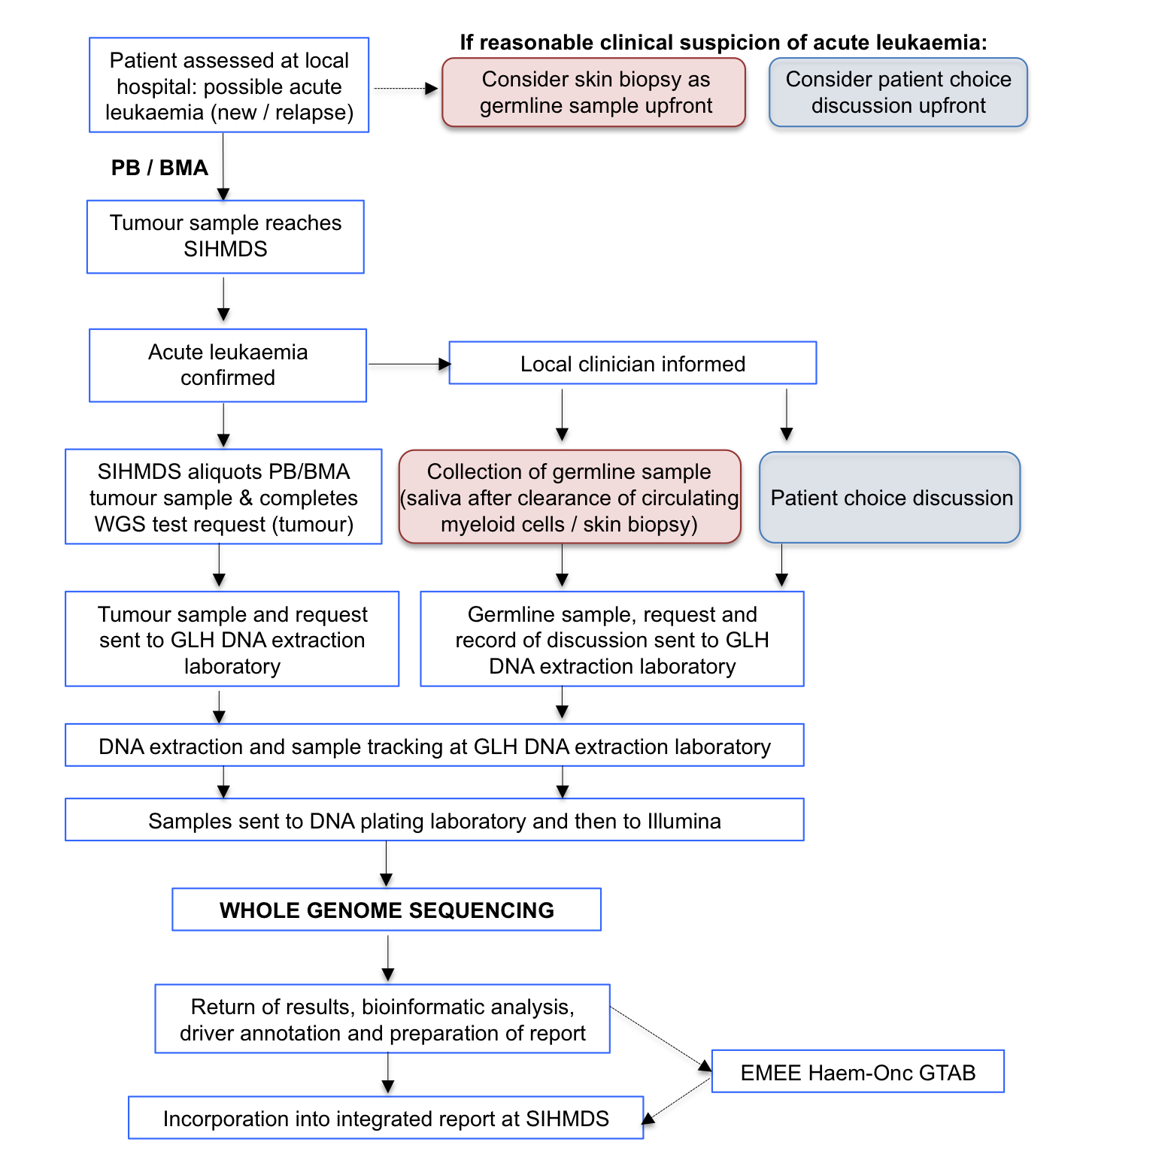

Appendix 1. Markers of malignant cell burden to be used in different conditions.
*Malignant cell percentage measured using morphology, immunohistochemistry or immunophenotyping
