Information for Patients with Colorectal Cancer

Your genetics appointment and testing for Lynch syndrome

You have been given this leaflet because of your diagnosis of bowel cancer (also known as colorectal cancer). Initial testing of your cancer (tumour) suggests it might be due to an inherited condition called Lynch syndrome. We would like to offer you a genetic blood test to help determine whether you have Lynch syndrome.

This leaflet aims to answer some of the most commonly asked questions about Lynch syndrome. If you would like more information, you can visit:
https://rmpartners.nhs.uk/lynch-syndrome-early-diagnosis-pathway/patient-information/

Lynch syndrome
Bowel cancer is the fourth most common cancer in the UK, and most diagnoses are due to older age, an unhealthy lifestyle or contributing conditions such as Crohn’s disease. However, a small proportion of bowel cancer is caused by inherited or genetic conditions; one of these conditions is called Lynch syndrome.
Most people with Lynch syndrome are well, but someone with Lynch syndrome has a higher chance of developing bowel cancer and there is an increased risk of endometrial (womb) cancer for women. Both men and women with Lynch syndrome have a slightly increased risk of developing cancers in other parts of the body than people in the general population.
People with Lynch syndrome are monitored through colonoscopic surveillance to reduce the chances of bowel cancer developing and can discuss options to manage their endometrial cancer risk.

Genes and DNA
To understand genetic testing for Lynch syndrome and what it means for you, we need to look at your DNA and genes.
DNA is the code our bodies use to make genes. Genes are the instructions that tell our body how to grow and develop and each have their own job to perform. Some of our genes determine what hair and eye colour we have and some are responsible for protecting us against diseases like cancer.
Inherited conditions are due to an alteration change (also known as a change or variant) in a particular gene, which can be passed on in a family. An altered gene may change the level of protection a family has against diseases such as cancer.
The Lynch syndrome genes are genes that protect us against cancer by repairing DNA mistakes that can occur when our cells are made. The Lynch syndrome genes are like police officers in our body, checking everything is working properly and protecting us against cancer. If these genes aren’t working properly, then mistakes can occur in our DNA code, which can result in a cancer (a bit like having less police officers protecting us against cancer).

Inheritance pattern
When we are conceived, we inherit two copies of every gene, one copy from our mother and one copy from our father. If one of our parents has Lynch syndrome, at the point of conception, they have a 50% chance of passing on their altered copy and 50% chance of passing on their unaltered copy. If a person inherits the altered copy, they will have Lynch syndrome. This is also known as an autosomal dominant inheritance pattern. This also means a person with Lynch syndrome has a 50% chance of passing on their altered gene each time they have a child.

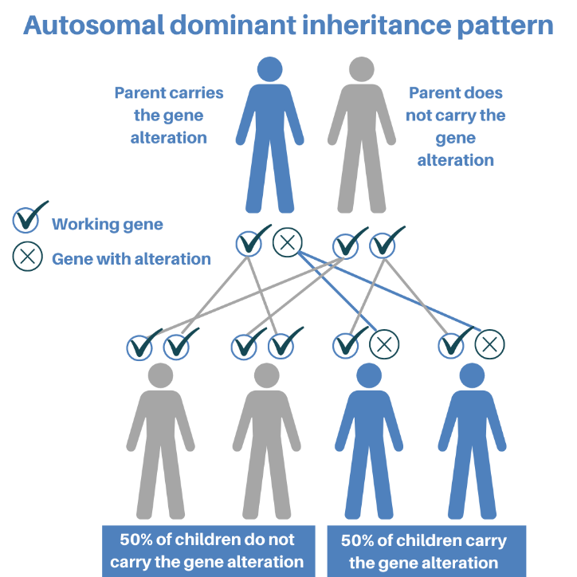
Figure created by North East Thames Regional Cancer Genetics Service

Genetic testing
Genetic testing for Lynch syndrome will involve having a blood test. DNA will be extracted from your blood to look for gene alterations (variants or changes) that cause disease or increase your risk of developing a disease. This testing takes approximately 3 months to complete.
Genetic testing for Lynch syndrome helps us to understand your and your family’s risk of developing cancer in the future. Positive test results will also help medical professionals understand the treatments you may require. There may be certain therapies available that can be tailored to you dependent on your test results.
Having genetic testing is optional. Your decision will not affect the standard of care you receive. However, knowing you have Lynch syndrome will give you and your family access to personalised treatments, advice and tailored surveillance programs. It will also enable testing of other family members to ensure they are kept safe and reduce the chance of further cancers developing in the family.

Genetic results
Genetic test results do not always give a clear answer. This is because the science of genetics is still in its infancy. For this reason, and for clarity, your results will be classified as: positive, uncertain or negative.

Positive: a disease causing genetic alteration (pathogenic variant) for Lynch syndrome is identified
This result would confirm the diagnosis of Lynch syndrome and provide an explanation for why you developed bowel cancer. Your cancer team may use this information in their management decisions and will discuss this with you further. You might be considered for additional therapies. You will be referred to Clinical Genetics who can discuss your result with you further, particularly the implications this has for your family members. They can support you to discuss this result with your family and can offer predictive genetic testing to your relatives (starting with parents, siblings, and children) as they might carry the same genetic change (alteration).

Uncertain: a genetic alteration (variant) of unknown clinical significance is found
A genetic change is found, however we cannot be certain it is the cause of your cancer, or if it is just a harmless change in the gene. You will be referred to Clinical Genetics who will assess your personal and family history to advise whether any further testing is possible and if any cancer screening is recommended to you or your family.

Negative: We do not find any genetic alterations (or variants)
This result doesn’t rule out an inherited condition. It might be that the limited knowledge we have about genetics means we are unable find a genetic change currently. You will be referred to Clinical Genetics who will assess your personal and family history to advise whether any further testing is possible and if any cancer screening is recommended to you or your family.

Your results will be given by your cancer team, who will also refer you to your local Clinical Genetics department. You will receive an appointment in clinical genetics if your result is positive. If your result is negative or uncertain, your local clinical genetics department will either send you an appointment for further discussion, or provide information by letter, dependent on their assessment. They may suggest further testing to help clarify your results, or may provide recommendations for your family members.

If you have any further questions about this test, or in relation to your ongoing cancer treatment, please contact your cancer team.

This leaflet was adapted with the permission of St Mark’s Hospital and RM Partners West London Cancer Alliance.

