T-cell and B-cell Clonality sample requirements
Depending upon the type of biopsy there are differential sample requirements which are outlined in the illustrations below. Please note that two H&E stained slides (first and last slide) are required for all cases and the lesional area should be marked on the H&E slides. A copy of the histopathology report should also be provided as this will aid in the molecular interpretation of these cases.
Tissue requirement
- Small, scanty samples (e.g. EBUS-FNA)
    - 1 x H&E, followed by 12 x 4 µm unstained sections, followed by 1 x H&E

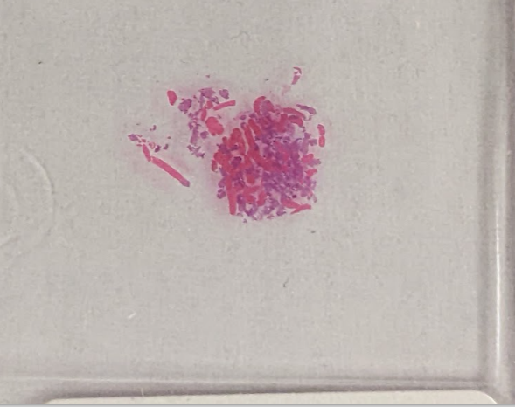

- Core biopsies and small biopsy samples
    - 1 x H&E, followed by 8 x 4 µm unstained sections, followed by 1 x H&E

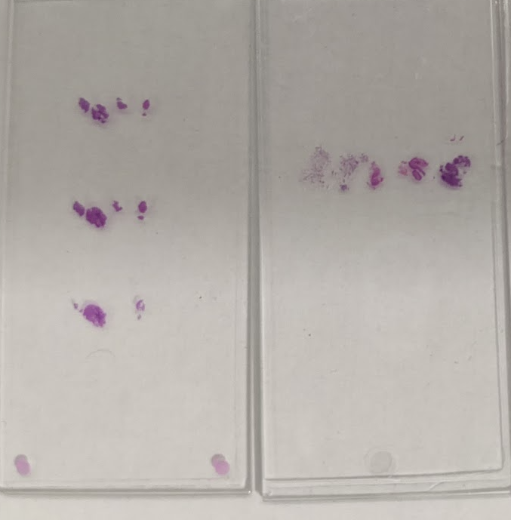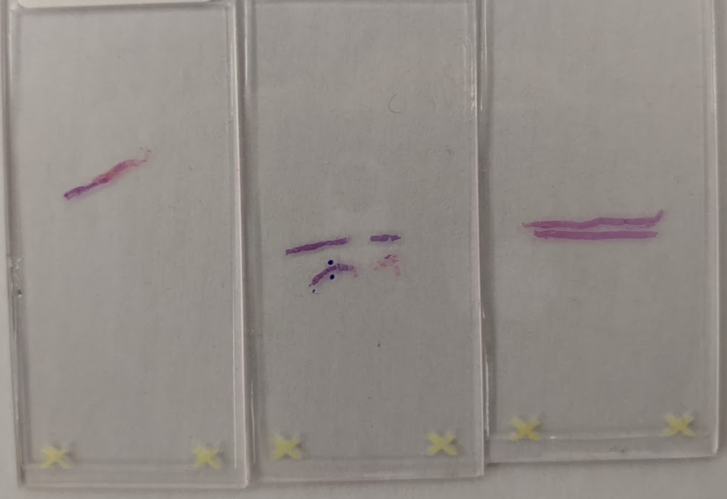

- Larger tissue samples
    - 1 x H&E, followed by 4-8 x 4 µm unstained sections, followed by 1 x H&E

- 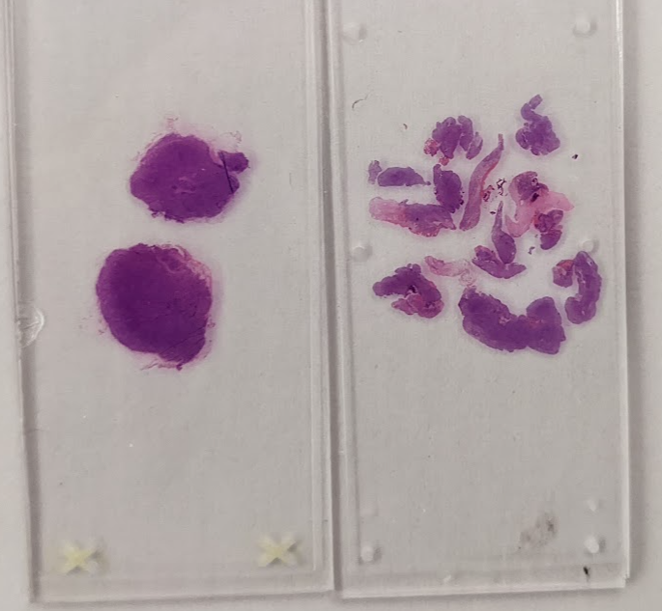
Marking the slides
Generally, marking is not needed. Please write ‘scrape all’ on the section. However, if there is a specific area of interest, please mark around all areas to be microdissected and write ‘Microdissect marked area’ on the slide.
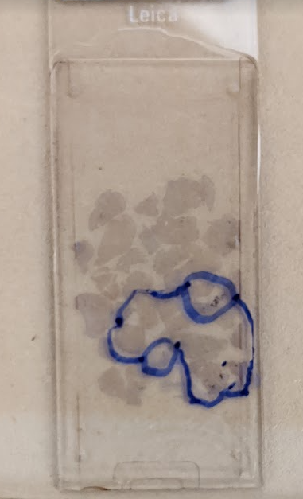
Need for purification
Purification is usually not needed, unless there is a large amount of blood, necrosis or melanin in the sample. If purification is needed, please write ‘Purify’, if not needed write ‘crude DNA’ on the slide.

